#include <iostream>
using namespace std;

struct bestCount
{
int FreqNum;
int freqNumCount;
};

class node
{public:
int data ;
node* nextPtr;

public:
node(int data){
this->data = data;
this->nextPtr = NULL;
};
node(int data, node* ptr){
this->data = data;
this->nextPtr = ptr;
};
~node(){};
};

class stack
{
public:

node* head;

stack(){
this->head = NULL;
};

void push(int num){
if (this->head == NULL)
{
node* n = new node(num);
this->head = n;
}
if (this->head != NULL){
node* n = new node(num , this->head);
this->head = n;

}
}

int pop(){
node* temp = this->head;
int popData=this->head->data;
this->head= head->nextPtr;
delete temp;
return popData;
}

bool isEmpty(){
if (this->head == NULL)
{
return true;
}
if (this->head != NULL)
{
return false;
}

}

int topElement(){
return (this->head->data);
}

~stack(){
node* temp = this->head;
while (temp!= NULL)
{
node* t= temp;
temp = temp->nextPtr;
delete t;
}

};

bestCount FrequencyCheck(stack s1){
node* temp = s1.head;
int bestcount=0;

int targetElement =0;
int count = 0;
bestCount b;
while (!s1.isEmpty())
{
count=0;

targetElement = s1.pop();
temp = s1.head;
while (temp!=nullptr)
{
if (targetElement == temp->data)
{
count++;
}

temp = temp->nextPtr;
}

if (count> bestcount)
{
bestcount = count;
b.FreqNum=targetElement;
b.freqNumCount= count;
}

}
return b;

}

};

int main(){

stack s1;
s1.push(1);
s1.push(2);
s1.push(3);
s1.push(4);
s1.push(5);
s1.push(4);
s1.push(6);

bestCount b1 = s1.FrequencyCheck(s1);

cout << "the most Frequent element is " << b1.FreqNum << " was found " << b1.freqNumCount << " times "<<endl;

return 0;
}
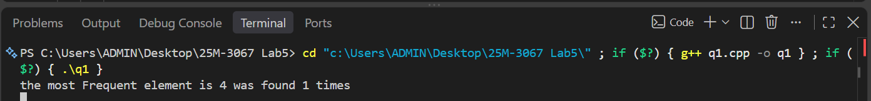Task 2:

#include <iostream>
#include <string>
using namespace std;

class node {
public:
char data;
node* nextPtr;

node(char data) {
this->data = data;
this->nextPtr = NULL;
}

node(char data, node* ptr) {
this->data = data;
this->nextPtr = ptr;
}

~node() {}
};

class stack {
public:
node* head;

stack() {
this->head = NULL;
}

void push(char num) {
if (this->head == NULL) {
this->head = new node(num);
} else {
node* n = new node(num, this->head);
this->head = n;
}
}

char pop() {
if (this->head == NULL) {
return '\0';
}
char popData = this->head->data;
node* temp = this->head;
this->head = this->head->nextPtr;
delete temp;
return popData;
}

bool isEmpty() {
return this->head == NULL;
}

char topElement() {
if (this->head == NULL) {
return '\0';
}
return this->head->data;
}

~stack() {
node* temp = this->head;
while (temp != NULL) {
node* t = temp;
temp = temp->nextPtr;
delete t;
}
}
};

bool isValidDelimiters(string& s) {
stack s1;
bool isValid = true;

for (int i = 0; i < s.length(); ++i)
{
if (s[i] == '{' || s[i] == '(' || s[i] == '[')
{
s1.push(s[i]);
}
else if (s[i] == '}' || s[i] == ')' || s[i] == ']')
{
if (s1.isEmpty()) {
isValid = false;
break;
}
char top = s1.topElement();
if ((s[i] == '}' && top != '{') || (s[i] == ')' && top != '(') || (s[i] == ']' && top != '['))
{
isValid = false;
break;
}
s1.pop();
}
}

if (isValid && !s1.isEmpty())
{
return true;
}

else{
return false;
}
}

int main() {
string s = “{[(2 + 3])}"; // not a valid delimeters
if (isValidDelimiters(s)) {

cout << "This is Valid Delimiters" << endl;
}

else {
cout << "This is not Valid Delimiters" << endl;
}
return 0;
}
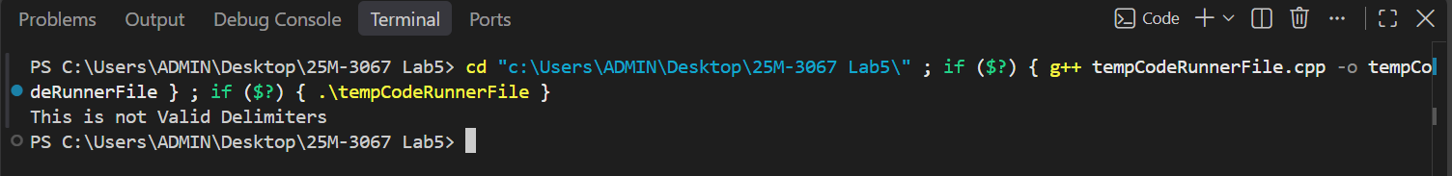

Task 3:

T

